**Project 2**

**Udacity Machine Learning Foundations Nanodegree**

Following is the work done as part of graduating for Machine-learning Foundation Nanodegree Unit – 2[Statistics]

**Problem description:**  
In a Stroop task, participants are presented with a list of words, with each word displayed in a color of ink. The participant’s task is to say out loud the *color of the ink* in which the word is printed. The task has two conditions: a congruent words condition, and an incongruent words condition. In the *congruent words* condition, the words being displayed are color words whose names match the colors in which they are printed: for example, RED, BLUE. In the *incongruent words* condition, the words displayed are color words whose names do not match the colors in which they are printed: for example, PURPLE, ORANGE. In each case, we measure the time it takes to name the ink colors in equally-sized lists. Each participant will go through and record a time from each condition.

The data are recorded and the time taken for incongruent condition is compared with the congruent results.

Following is the report of the data from the spreadsheet at the following address:

<https://www.google.com/url?q=https://drive.google.com/file/d/0B9Yf01UaIbUgQXpYb2NhZ29yX1U/view?usp%3Dsharing&sa=D&ust=1499120159475000&usg=AFQjCNFJ_LrV1gkQ1DmfvX3NHUddazc_gA>

**Data**

|  |  |
| --- | --- |
| **Congruent** | **Incongruent** |
| 12.079 | 19.278 |
| 16.791 | 18.741 |
| 9.564 | 21.214 |
| 8.63 | 15.687 |
| 14.669 | 22.803 |
| 12.238 | 20.878 |
| 14.692 | 24.572 |
| 8.987 | 17.394 |
| 9.401 | 20.762 |
| 14.48 | 26.282 |
| 22.328 | 24.524 |
| 15.298 | 18.644 |
| 15.073 | 17.51 |
| 16.929 | 20.33 |
| 18.2 | 35.255 |
| 12.13 | 22.158 |
| 18.495 | 25.139 |
| 10.639 | 20.429 |
| 11.344 | 17.425 |
| 12.369 | 34.288 |
| 12.944 | 23.894 |
| 14.233 | 17.96 |
| 19.71 | 22.058 |
| 16.004 | 21.157 |

**Data Report:**

**Symbols used:**

Mean of congruent samples - X̅C

Mean of incongruent samples - X̅I

Standard deviation – σ

Population congruent mean – µC

Population incongruent mean - µI

**Descriptive Statistics**

As per the data, the following can be inferred:

Independent variable : **Type** **of condition** – Congruent (word color matches with the word)/Incongruent (Word color does not match with the color)

Dependent variable : **Time taken** by the users to complete/say out loud the words test under a given condition

Sample size: 24

Mean congruent, X̅C= 14.05

Mean Incongruent, X̅I = 22.01

Standard deviation, σ = 4.86

By looking at the data, the time taken to complete the incongruent test can be compared with the congruent time taken.

**Sample plots:**

**Inferential Statistics**

**Defining Hypothesis:**  
Null hypothesis : Population Incongruent mean = Population congruent mean i.e. **µI = µC**

Alternative hypothesis : Population Incongruent mean > Population congruent mean i.e. **µI > µC**

Population Incongruent mean < Population congruent mean i.e. **µI < µC**

Population Incongruent mean != Population congruent mean i.e. **µI != µC**

**Type pf test proposed**

Since the sample is the same, Repeated measures test (two condition test) can be performed on the data set because the user performance is based on two different conditions (Congruent & Incongruent).

It is a one-tailed test on the negative side.

The above decision based on the assumptions/reasons below:

1. The distribution is Gaussian
2. We have less than 30 samples
3. The mean, standard deviation of the population is unknown, hence the t-test.
4. Same sample is tested at two different points of time, hence the repeated measures test.
5. Further assuming, α level=0.05

**Characteristics of the data**

* Mean differenceµ= X̅C - X̅I = -7.96
* Degrees of freedom, df: 23
* Standard error, SEM = 0.993
* t-statistic= -8.020938234
* t-critical= -1.714

Reject null hypothesis as t-statistic is much lesser than t-critical value.

Alternative hypothesis holds good for the data.

Confidence Interval, CI: (-9.67, -6.27)

Cohen’s d= -1.637219949

r2= 0.108430147

**Conclusion**

It can be concluded that users took 6 to 10 seconds lesser on the congruent condition.

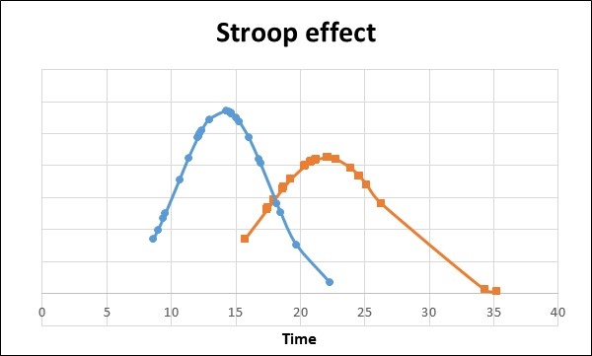

Since this was an experimental test, a conclusion can be made that the incongruent condition caused an increase in time to complete the test by the users.